WEB-PEN Scanner (run test)

- 1. Test Environment
  - Operating System: Windows 11
  - Python Version: 3.13.x
  - Framework: Flask 3.x
  - Database: SQLite
  - Browser: Google Chrome
  - Testing Tool: Web-Pen Scanner
  - Target: Pentest Ground – Authorized Vulnerable Testing Environment
  - Project Version: v1.0
  - Test Date: 16 October 2026

- 2. Prerequisites
  - Python 3.x
  - Git
  - Web browser
  - Project dependencies installed using requirements.txt
  - Authorized vulnerability-testing target Install dependencies:
    - python -m pip install -r requirements.txt
  - Create virtual environment:
    - python -m venv .venv
  - Activate on Windows:
    - .venv\Scripts\activate

- Run this python file run.py on terminal or powershell:
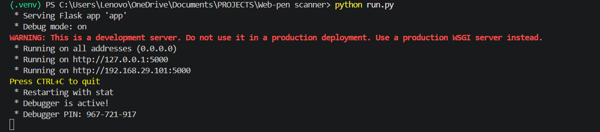

- Open localhost on your browser to open the webapp:
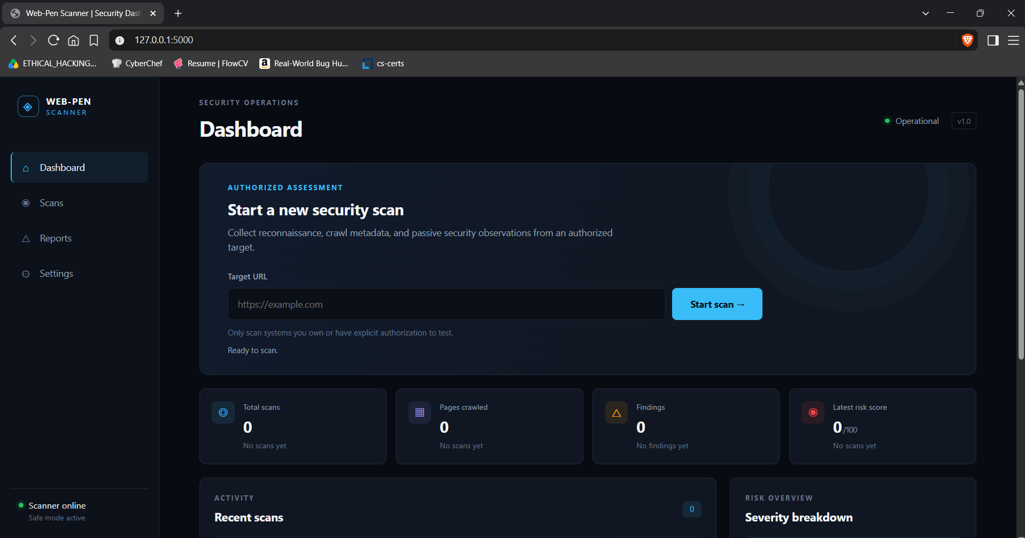

- Testing API health:
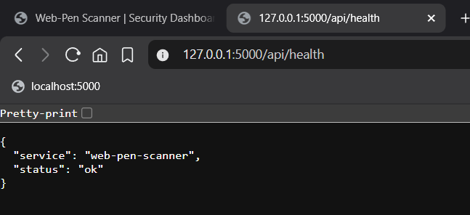
- Enter the website which u want to scan in scanner’s search bar:
(we are using https://pentest-ground.com:81/)
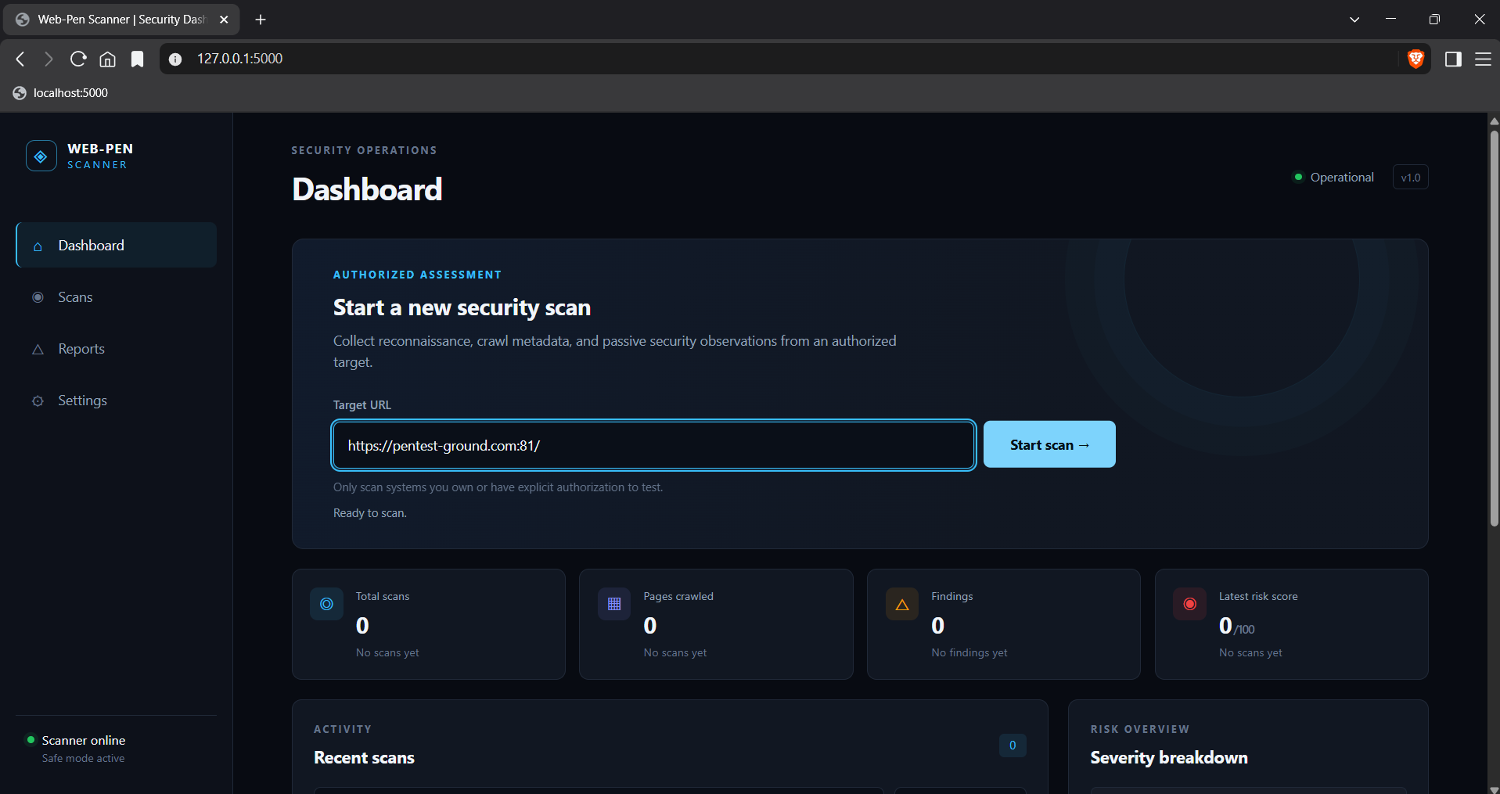

- The output:
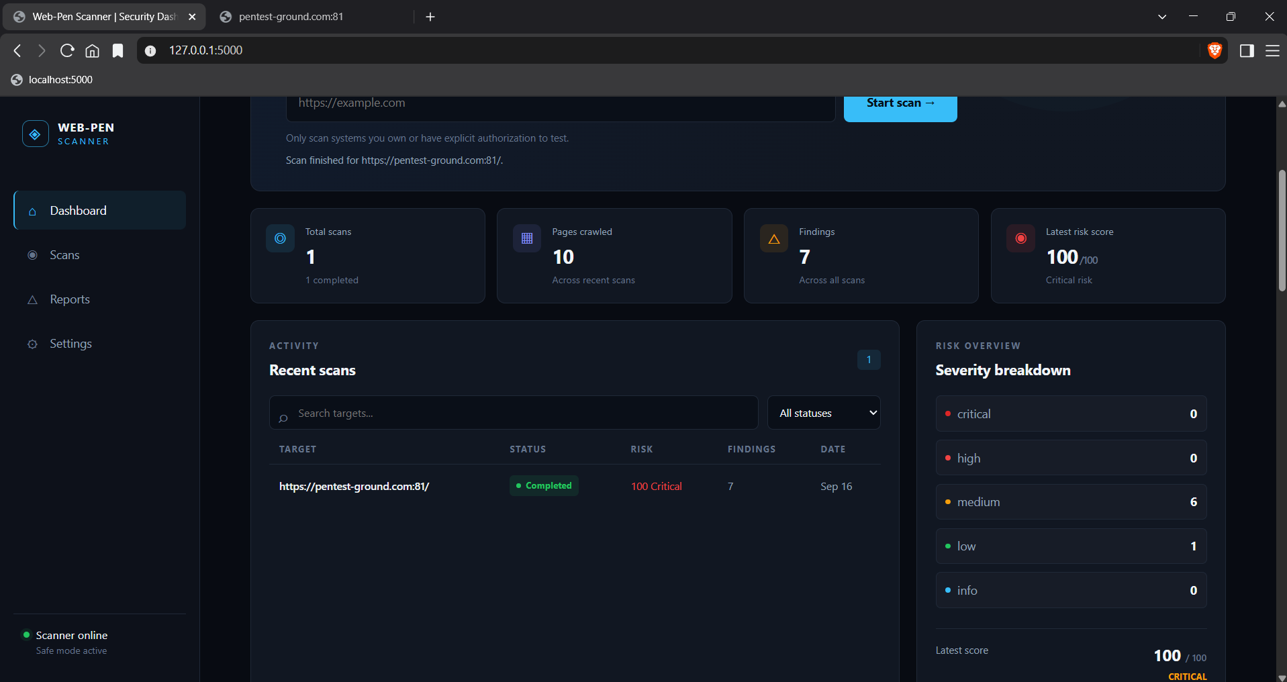
- Scan details:
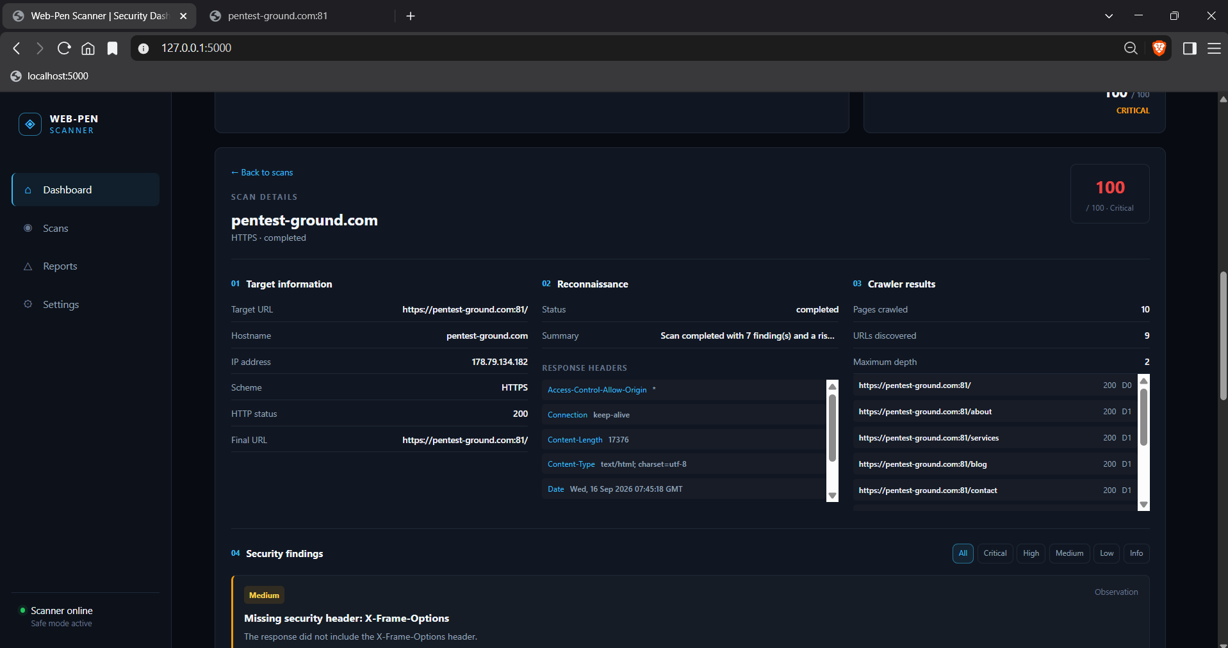
- After done scanning and saving the report goto terminal and press ctrl+c to close/shut the site i.e, for exit.

